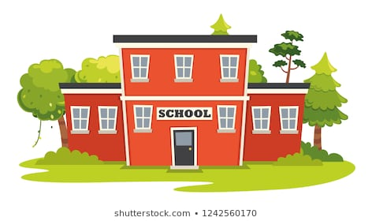
Pre –K Supply List
- A ream of copy paper
- 2 glue sticks
- 1 Regular glue
- 1 Box of crayons ( fat ones)
- 1 Box of markers (fat ones)
- Fat pencils
- 1 safety scissors
- 1 preprimary marble notebook
- Play Doug
- Dry erase board
- Dry erase markers
- Dry erase eraser
- Pencil sharpener (for fat pencils)
- Popsicle sticks
- Outdoor chalk
- Ream of multi color construction paper
- Headphones

Additional items for fully remote students
- Collage materials (tissue paper, pom poms, stickers, ETC.)
- Yarn
- Primary colors finger paints
- Manipulatives (anything that can be counted. Example pasta, beans, ETC.)
- Flash cards (Numbers, shapes and alphabet.)

Additional items for hybrid students
- Extra face mask for your child
- Seasonal change of clothing
- Personal soft comfort toy
- Individual pocket size tissues
- Individual size hand sanitizer
- 1 pocket folder
- Medium size book bag (for children to place their change of clothing and personal school supplies in.)
- Water bottle
- Medium size shower caddy (For children to place center items in.)
- 4 passport size picture of child
- 2 family pictures
- Medium size milk crate to store children’s personal belongings (possible)
- Cot size fitted sheet and light blanket (possible)

Hybrid parents please:
- Label all children’s materials
- Put change of clothing, extra mask and all students school supplies in their backpack.
Classroom Donations
- 2 packs of flushable baby wipes
- 2 rolls of paper towels
- 1 box of tissues
- 3 Disinfectant Wipes
- 1 bottles of disinfectant all purpose cleaner
- 2 liquid hand soaps pumps
- 2 Hand sanitizer pumps
- 2 large cans of Lysol disinfectant spray
- 2 boxes of gallon size zip lock bags with slider lock
- 2 boxes of sandwich size zip lock bags with slider
- 2 boxes of 2.5 gallon zip lock bag with slider lock

